
SYMBIOSIS INSTITUTE OF TECHNOLOGY, PUNE
Symbiosis International (Deemed University)
(Established under section 3 of the UGC Act, 1956)
Re-accredited by NAAC with ‘A’ grade (3.58/4) | Awarded Category – I by UGC
Founder: Prof. Dr. S. B. Mujumdar, M. Sc., Ph. D. (Awarded Padma Bhushan and Padma Shri by President of India)

Assignment No. 13

Subject: | DevOps Lab
TCODE: | TE7950
Name of Student | Yash Patel
PRN No. | 23070122235
Branch | CSE, Batch (2023-27), L4
Academic Year &  Semester | 25 – 26, Sem VII
Date of Performance | 23rd July, 2026
Title of Assignment: | Kubernetes Service & Networking
Theory: | A Kubernetes Service is an abstraction that provides a stable network endpoint for accessing one or more Pods in a Kubernetes cluster. Since Pods are temporary and their IP addresses may change, a Service uses labels and selectors to route incoming traffic to the appropriate Pods. A NodePort Service exposes the application outside the cluster by allocating a port on each cluster node, allowing external access to the application. During local development, kubectl port-forward can also be used to securely forward traffic from a local machine to a Kubernetes Service for testing and verification. This approach simplifies communication between applications and ensures reliable access to containerized workloads.  Commands Used  - Created the Kubernetes Deployment:  kubectl apply -f web-deployment.yaml  - Verified that the Pods were running:  kubectl get pods  - Created the Kubernetes Service:  kubectl apply -f web-service.yaml  - Displayed the available Kubernetes Services:  kubectl get service  - Displayed detailed information about the Service:  kubectl describe service web-app-service  - Displayed the Service endpoints:  kubectl get endpoints  - Displayed the running Pods with labels:  kubectl get pods --show-labels  - Displayed the application logs:  kubectl logs web-app-deployment-<pod-name>  - Forwarded the Kubernetes Service to the local machine:  kubectl port-forward service/web-app-service 8085:80  - Deleted the Kubernetes Service:  kubectl delete -f web-service.yaml  - Deleted the Kubernetes Deployment:  kubectl delete -f web-deployment.yaml
Implementation: | Step 1: Create the Kubernetes Service YAML  Created Kubernetes Service Manifest — Created the web-service.yaml file defining a Kubernetes NodePort Service to expose the Flask web application running in the Kubernetes Pods.  Step 2: Apply the Servic  Applied Kubernetes Service — Applied the Kubernetes Service manifest using kubectl apply, creating a NodePort Service for the deployed Flask application.  Step 3: Find the Service Information  Verified Kubernetes Service — Verified the Kubernetes NodePort Service and identified the assigned NodePort (30649) used to expose the Flask web application outside the Kubernetes cluster.  Step 4: Access the Application  Accessed Application Through Kubernetes Service — Used kubectl port-forward to forward the Kubernetes Service to the local machine and successfully accessed the Flask web application at http://localhost:8085, verifying that it was running correctly.  Step 5: Clean Up  Deleted Kubernetes Service — Removed the Kubernetes Service using the kubectl delete command, cleaning up the networking resources created for the application.  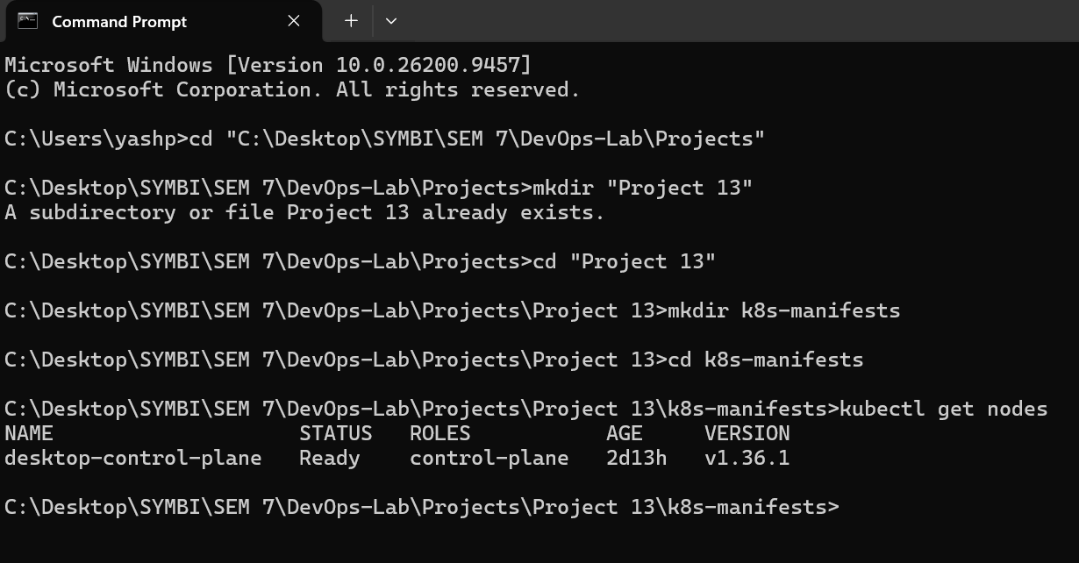  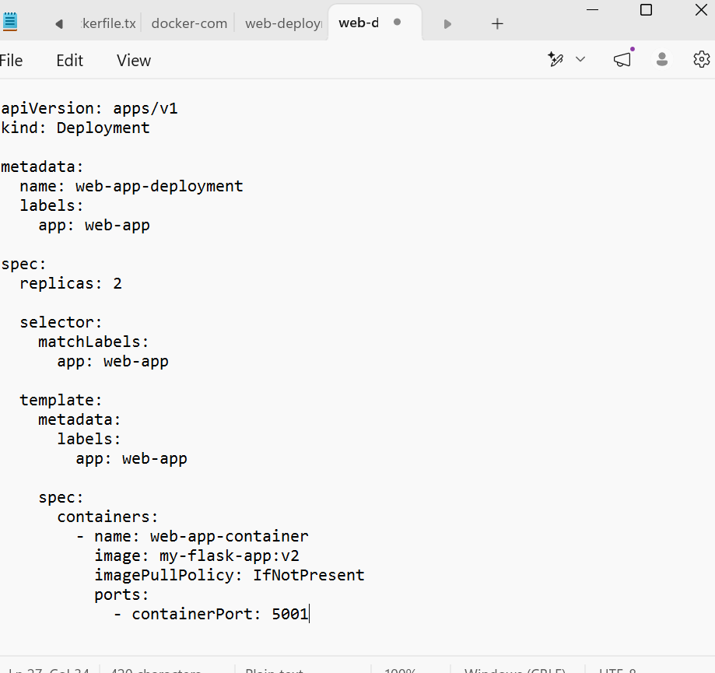  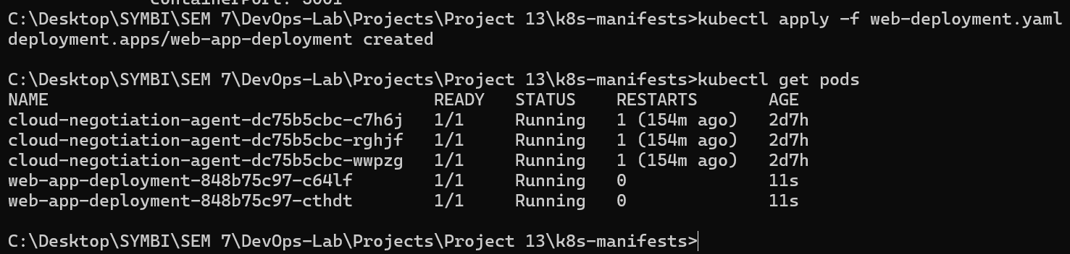  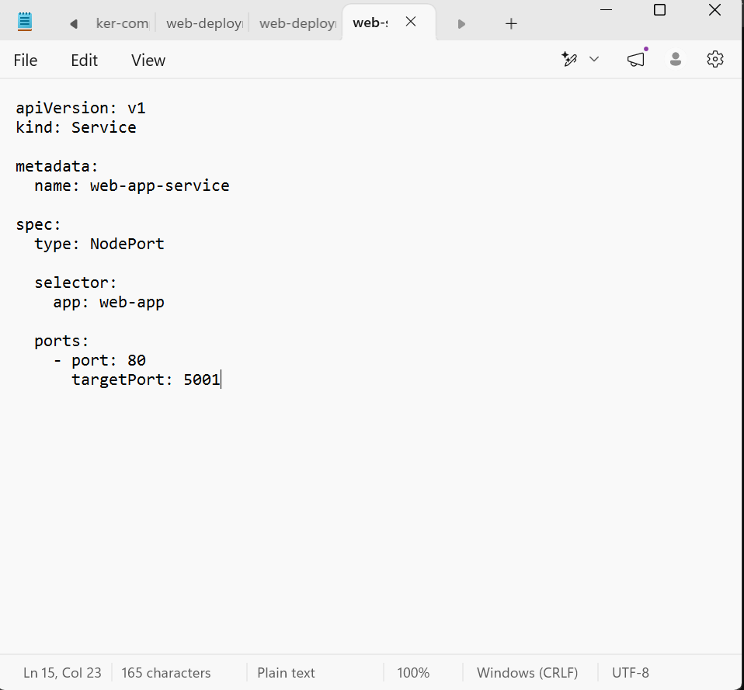  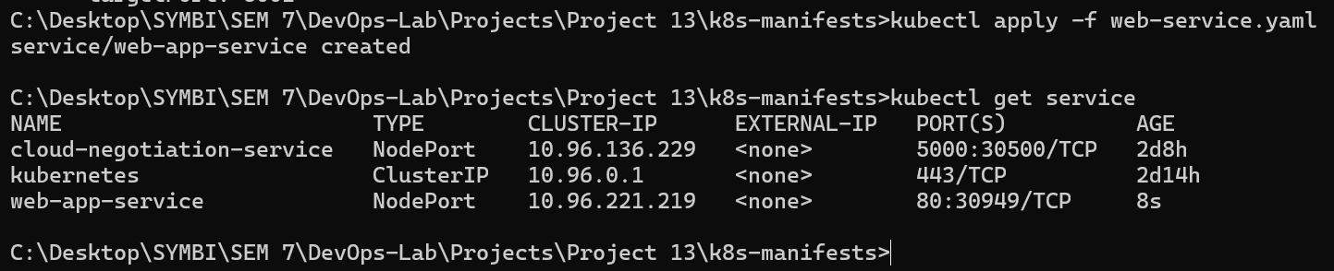  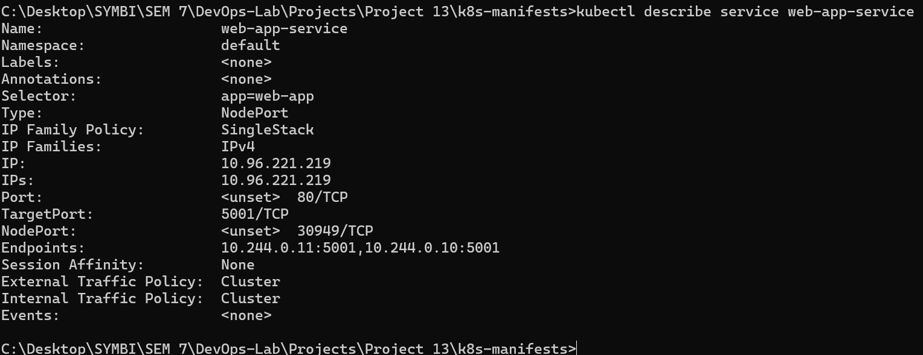  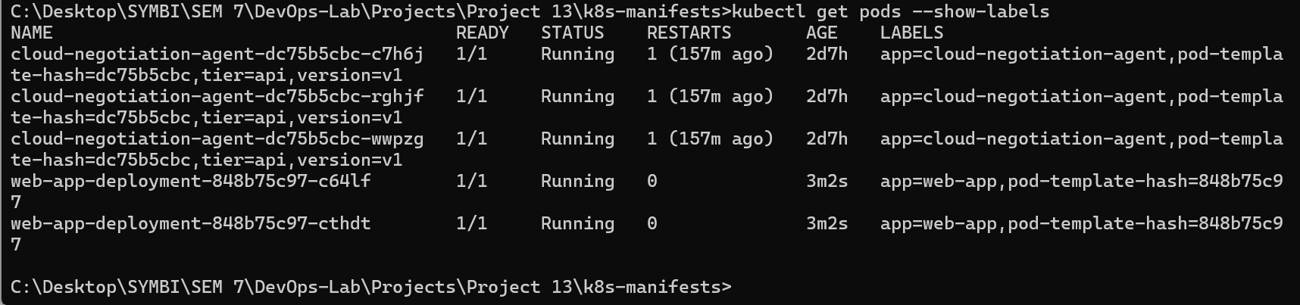  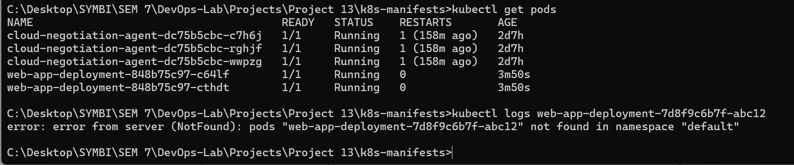  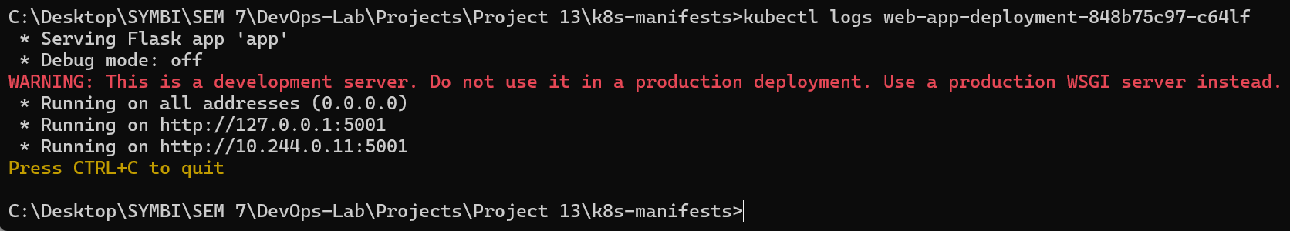  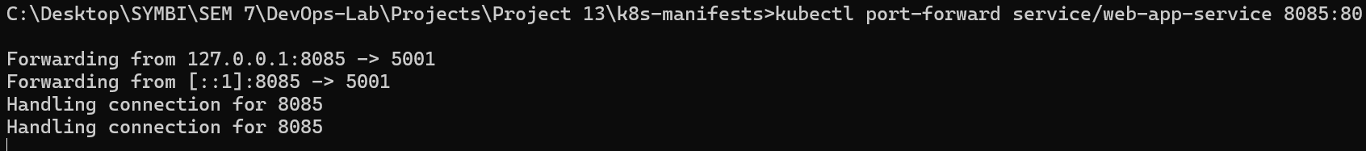  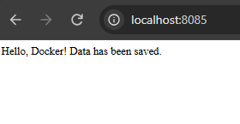  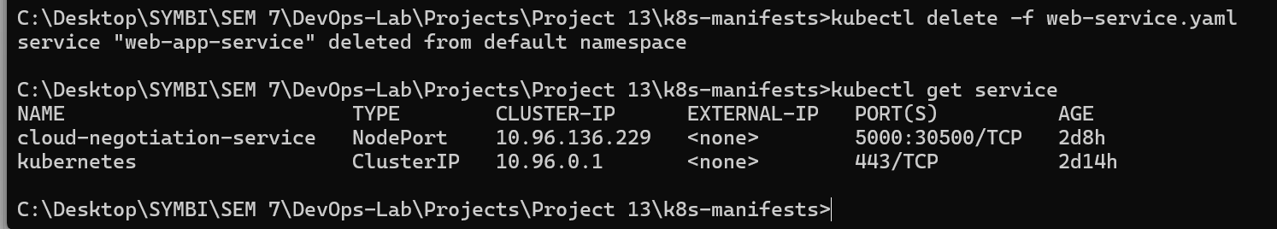

Subject Faculty Name: Prof. Arijit Dutta

